**A/7/16 (2023)**

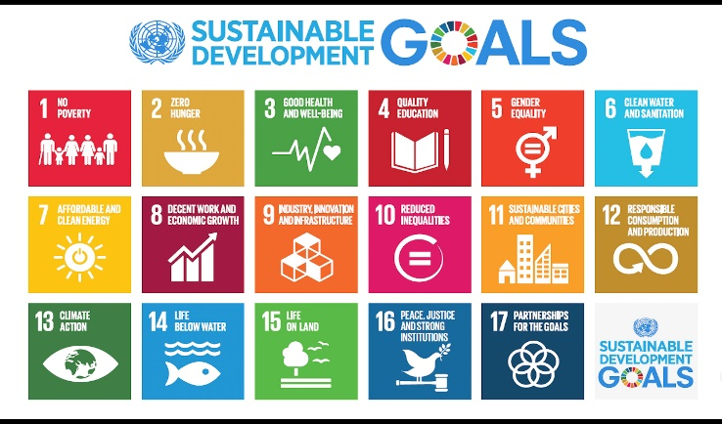

Distribution: General

17 July 2023

***United Nations Decade of Sustainable Energy For All (2014-2024)***

**Twelfth Meeting of the Executive Council**

**Via Telephone and Videoconferencing**

**22 May 2023**

**Agenda Item (2) Organisation of Work (a) Appointment of New Officers (Belize and Tuvalu 2023-2025)**

