Second Session of the Assembly of SIDS DOCK
UN Headquarters, ECOSOC Chamber
New York, New York
24 September 2016

Report of the Depositary of the Statute Establishing
the Small Island Developing States Dock (SIDS DOCK)

- The instrument establishing the Small Island Developing States DOCK, (SIDS DOCK Statute) was opened for signature at the Third International Conference on Small Island States in Apia, Samoa from 1st to 5th September 2014. It remained open for signature at the Permanent Mission of Belize to the United Nations in New York acting on behalf of the Government of Belize as Depositary of the Statute until its entry into force.

- The SIDS DOCK entered into force on 27th September 2015 being the thirtieth day after the date of deposit of the ninth instrument of ratification.

- Accordingly, on 29th September 2015, Belize submitted the SIDS DOCK Statute to the United Nations Treaty Section in New York for registration pursuant to Article 102 of the Charter of the United Nations. A certificate confirming registration as of 1 February 2016 was issued on 3 June 2016 and is attached hereto as Annex 1.

- The SIDS DOCK Statute remains open for ratification or accession at the Permanent Mission of Belize to the United Nations in New York. The Statute currently has 20 signatories and a total of 15 state parties. A table of the status of thee Statute is attached hereto as Annex 2.

A/2/3

ANNEX 1

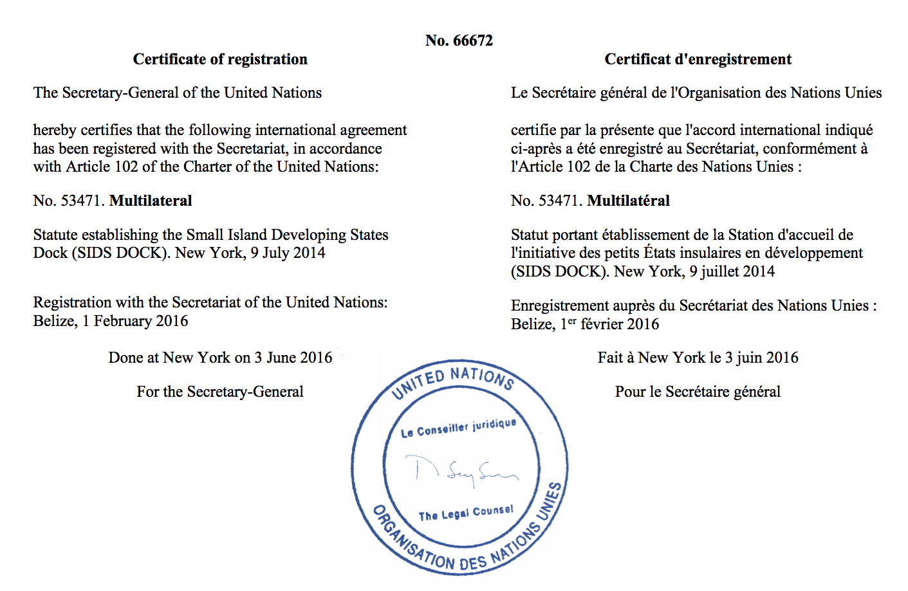

A/2/3

ANNEX 2

Statute of the Establishment of Small Island Developing States Dock (SIDS DOCK)

Entry into force: 27 September 2015, in accordance with Article XIX
Registration: United Nations 1 February 2016
Status: Signatories 20; Parties 15
Text: Permanent Mission of Belize to the United Nations
Note: The Instrument was opened for signature on 1 September 2014

 | PARTICIPANT | SIGNATURE | Ratification(R) , Accession (a), Acceptance (A), Approval (AA), Succession (d)
1 | Antigua and Barbuda |  | 07 June 2016 a
2 | Bahamas (Commonwealth of the) | 1 September 2014 | 24 September 2015 R
3 | Barbados | 1 September 2014 | 06 July 2015 R
4 | Belize | 1 September 2014 | 31 march 2015 R
5 | Cabo Verde | 1 September 2014
6 | Cook Islands | 1 September 2014 | 27 April 2015 R
7 | Dominica (Commonwealth of ) | 4 September 2014 | 16 September 2014 R
8 | Dominica Republic | 1 September 2014
9 | Fiji (Republic of) | 1 September 2014
10 | Grenada | 1 September 2014 | 17August 2015 R
11 | Guinea Bissau | 1 September 2014
12 | Kiribati | 1 September 2014
13 | Mauritius |  | 07 March 2016 a
14 | Micronesia (Federated States of) | 4 September 2014
 | PARTICIPANT | SIGNATURE | Ratification(R) , Accession (a), Acceptance (A), Approval (AA), Succession (d)
15 | Nauru (Republic of) | 3 September 2014
16 | Niue | 1 September 2014
17 | Palau (Republic of) | 1 September 2014
18 | Saint Kitts and Nevis | 1 September 2014 | 28 August 2015 R
19 | Saint Lucia |  | 02 October 2015 a
20 | Saint Vincent and the Grenadines | 1 September 2014 | 25 September 2014 R
21 | Samoa (Independent State of) | 1 September 2014 | 13 August 2015 R
22 | Seychelles (Republic of) | 1 September 2014 | 25 September 2015 R
23 | Tonga (Kingdom of) |  | 15 December 2015 a
24 | Tuvalu | 1 September 2014 | 1 September 2014 R

