A/2/DC/2
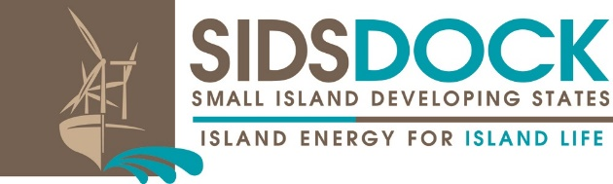
Distribution: General
19 September 2016

United Nations Decade of Sustainable Energy For All (2014-2024)

Second Session of the Assembly of SIDS DOCK
UN Headquarters, ECOSOC Chamber
New York, New York
24 September 2016
Agenda Item: 8

Decision of the Work Programme and Budget for 2016 - 2021

The Assembly,
Affirming its urgency to have the SIDS DOCK Organization and in particular its Secretariat established and fully functional to begin responding effectively to the needs of the SIDS Community, in accordance with the purposes and principles of the SIDS DOCK Statute,
Acknowledging SIDS DOCK’s crucial role in assisting small island developing states in strengthening their abilities to advance the widespread and increased adoption and use of renewable energy;
Recalling Article X of the Statute on budget of the SIDS DOCK,
Having considered the work programme and budget for 2016 - 2021 as proposed in EC/2/3,
Noting that the establishment of the SIDS DOCK Secretariat in Belize is imminent, and that the Host Country Agreement is under consideration,
Taking into account the views expressed by the Members during the consideration of this item,
1. Decides to adopt the work programme and budget of the organization as contained in EC/2/3 as document A/2/7, comprising:
- Expenditures for staffing/personnel, operational, miscellaneous costs and management fees and contingency amount to approximately US$6,856,261;
- Tiers of funding, including proposals on new sources of funding and long-term expected income.
2. Urges the Council and the Interim Secretariat:
• to further clarify and set priorities for the 2016-2021 work programme, including the estimated costs for sub-programmes and activities;
• to prepare a strategic framework for 2016 -2021 that clearly defines vision, strategic direction, objectives, and activities for consideration at the third session of the Assembly
• to begin development of a results-orientated 2016- 2021 work programme and budget,
. to work together to seek innovative options for future funding opportunities for the Organization, in accordance with the provisions of Article X of the Statute, and to report on the progress made at the third session of the Assembly;

