Third session of the SIDS DOCK Assembly
United Nations
New York, NY 10017
23 September 2017

NOTE OF THE SECRETARY-GENERAL
SIDS DOCK PRESENCE IN VIENNA

DIPLOMATIC LIAISON OFFICE ON KNOWELDGE MANAGEMENT AND INNOVATION

- Background
SIDS DOCK is a unique mechanism, as its leadership is represented by high-level officials - Heads of State and Government, Ministers of Foreign Affairs, Ministers of Energy and Environment, and Ambassadors and Permanent Representatives to the United Nations (UN). Like the UN-System, and now that SIDS DOCK is part of that system, it is expected that in any given year, the Secretariat will deal with representatives of all 32-plus SIDS countries, including Heads of State and Government, as well as others who will interface with the Secretariat in an official capacity. The uniqueness of SIDS DOCK defies the business as usual image of the “begging bowl cap-in-hand facilitator.” SIDS DOCK presents an image of a professionally polished “project pipeline investment facilitator”. Success projects require both technical and political foundations.

In 2010, at the United Nations Framework Convention on Climate Change (UNFCCC) Conference of Parties meeting (COP 16), in Cancun, Mexico, Small Island Developing States launched the SIDS Sustainable Energy and Climate Resilience Initiative - SIDS DOCK - as the SIDS-owned mechanism to bring about the transformation of the SIDS energy sector, which is considered by islands as the most effective and sustainable manner to build resilience to climate change. The SIDS DOCK goal is to increase energy efficiency by 25 percent (2005 baseline) and to generate a minimum of 50 percent of electric power from renewable sources and a 50 percent decrease in conventional transportation fuel use by 2033: Island Energy for Island Life 25-50-25 by 2033.

The journey begun in 2009, when Members of the Alliance of Small Island States (AOSIS) or SIDS countries began the process of establishing the organisation through a Memorandum of Agreement (MOA), and on 1 September 2014, twenty (20) of these States signed the Statute Establishing the SIDS DOCK, during the Ceremony for the Opening of Signature of the Statute Establishing the SIDS DOCK, held on the margins of the United Nations Third International Meeting on Small Island Developing States, in Apia, Samoa, in September 2014.

In March 2014, SIDS DOCK, Austria and UNIDO, signed a Memorandum of Understanding (MOU) establishing a network of regional sustainable energy centres for SIDS in Africa, the Caribbean, Pacific and Indian Ocean regions to act as technical implementation hubs for activities of SIDS DOCK and respective regional organisations. The SIDS DOCK Statute came into force on 27 September 2015, and members convened an official launch ceremony of the SIDS DOCK on 30 September 2015, on the margins of the General Debate of the 70th session of the United Nations (UN) General Assembly, in New York, to celebrate the legal entry into force of the SIDS DOCK Treaty, recognising the establishment of the historic intergovernmental organisation vested with the full powers of the United Nations.

In December 2015, on the margins of the UNFCCC COP 21, in Paris, France, the First Session of the SIDS DOCK Assembly was held, where members were elected to serve as President, Vice Presidents, and on the Executive Council. In June 2016, the First Meeting of the SIDS DOCK Executive Council was held in New York, where the SIDS DOCK Registration Certificate from the UN Secretary-General, received on 3 June 2016, was tabled at the meeting. Belize is the SIDS DOCK Host County, and the Belize-based Caribbean Community (CARICOM) Climate Change Centre (CCCCC/5Cs) is the designated Interim SIDS DOCK Secretariat. With support of UNIDO, the Caribbean Centre for Renewable Energy and Energy Efficiency (CCREEE) was established in Bridgetown, Barbados in 2016, and the Pacific Centre for Renewable Energy and Energy Efficiency was inaugurated on 26 April 2017, in Nuku’alofa, Tonga. The ECOWAS Centre for Renewable Energy and Energy Efficiency (ECREEE), based in Cabo Verde, acts as the SIDS DOCK hub for African SIDS. After strengthening its field presence, SIDS DOCK intends to strengthen its ties at the international level through a SIDS DOCK Diplomatic Liaison Office on Knowledge Management and Innovation, to be hosted at an international energy hub. In this context, first discussions with UNIDO and the Government of Austria are held.

- HOSTING PROPOSAL
It is proposed that the SIDS DOCK Diplomatic Liaison Office on Knowledge Management and Innovation is hosted by the United Nations Industrial Development Organization (UNIDO) with the support of the Austrian Government. UNIDO has supported the establishment of the SIDS DOCK from the very beginning through its activities under the Global Network of Regional Sustainable Energy Centers Platform. Based on the signed MOU between the Government of Austria, UNIDO and SIDS DOCK in 2014, the establishment of a sub-network of regional sustainable energy centers for SIDS has made major progress.

The network is acknowledged as an official Sustainable Development Goal (SDG 7: Affordable and Clean Energy) partnership of the SAMOA Pathway. The regional centers based in Tonga, Barbados and Cabo Verde will act as technical implementation and innovation hubs of the international SIDS DOCK Organization and the respective regional organizations. Moreover, the centers will facilitate SIDS-SIDS cooperation on common issues and adapted island solutions. In June 2015, the Vienna Declaration on the SE4ALL Network of Regional Sustainable Energy Centers for SIDS in Africa, Caribbean, Indian Ocean and the Pacific regions was adopted by the SIDS DOCK Steering Committee and presented at the 2015 Vienna Energy Forum.

The case for a SIDS DOCK Diplomatic Liaison Office on Knowledge Management and Innovation is based on the UK-Model. The UK Government set up its Diplomatic Liaison Office in response to a situation where Embassies and High Commissions in the UK are seeing a marked increase in enquiries from foreign companies and institutional, sovereign and private funds seeking to invest in or buy from UK companies. The government believes it is important for these buyers and investors to meet the right UK organizations.

The SIDS DOCK image is solidly in line with UNIDO’s promotion of industrial development for poverty reduction, inclusive globalization and environmental sustainability. UNIDO is the only UN Agency strategically positioned with the capacity to assist and support SIDS DOCK to promote its goals of 25-50-25 by 2033. UNIDO offers technical services with high relevance for small-scale industries in SIDS. UNIDO is a specialised Agency of the United Nations to promote inclusive and sustainable industrial development. Recently, the United Nations General Assembly and the G20 have called on UNIDO to lead the third Industrial Development Decade for Africa 2016-2025. The organisation operationalizes its mandate through three pillars: advancing economic competitiveness, creating shared prosperity, and safeguarding the environment.

The Agency has a long-standing track-record in assisting developing countries in strengthening domestic industrial value chains through targeted interventions in the areas of policy, capacity development, knowledge management as well as the promotion of investment, innovation and entrepreneurship. Some of the support areas are: industrial upgrading, product quality certification and standards, trade, capacity building, the establishment of SME clusters, as well as industrial and technology parks. An important focus lies also on reducing the negative environmental externalities of industrial processes, by making industries greener and promoting the commercialisation of innovative clean technology solutions and businesses. In this context, UNIDO is promoting cleaner production, resource efficiency, circular economy, as well as renewable energy and energy efficiency.

Vienna is a location that brings with it the strongest institutional ties to SIDS DOCK both in focus, sustainable energy, and financing partnerships, in the form of UNIDO, and the deep interest and firm support shown by the Government of Austria, in the transformation of the SIDS Energy Sector through the establishment of the SIDS Regional Centres, in partnership with SIDS DOCK and UNIDO. The SIDS Regional Centres is a powerful and visible manifestation of the relevance of the generosity of the people and government of Austria, in helping to kick-start, in 2014, the biggest transformation in the energy sector in Small Island Developing States (SIDS), in modern history

- JOINING THE VIENNA ENERGY HUB
Vienna is a hub for international organizations with sustainable energy and environmental mandates. Vienna is an important place of energy and environmental diplomacy and debate. The Vienna Energy Forum (VEF) is organized biannually by the Government of Austria, UNIDO and IIASA. The Government of Austria and Vienna-based organizations, particularly UNIDO and IIASA, were the pioneering promoters of SE4All in the EU and UN context. The origins of the initiative are strongly rooted in Vienna.
Austria and UNIDO provided financial and analytical key support for the Global Energy Assessment (GEA). The GEA was led by the Vienna-based IIASA, and provided the scientific basis for SDG-7. SIDS DOCK will benefit from the expertise and technical cooperation experience of Vienna-based organizations and public-private partnerships with energy and environmental mandates. Most energy organizations are members of the “Vienna Energy Club” founded in 2009. The Club meets two to three times a year, based on a rotating host principle. Currently, the following relevant international organizations and multi-stakeholder partnerships with energy mandates are based in Vienna:

- Sustainable Energy For All Partnership (SE4ALL)
- United Nations Industrial Development Organization (UNIDO)
- Organization of the Petroleum Exporting Countries (OPEC)
- International Atomic Energy Agency (IAEA)
- International Institute for Applied Systems Analysis (IIASA)
- OPEC Fund for International Development (OFID)
- Organization for Security and Co-operation in Europe (OSCE)
- Energy Community for Southern and Eastern Europe (EnC)
- The Climate Technology Centre and Network (CTCN), co-hosted by UNIDO and UNEP
- Private Financing Advisory Network (PFAN), hosted by UNIDO
- Global Network of Regional Sustainable Energy Centers Platform, hosted by UNIDO
- Network for Resource Efficient and Cleaner Production (RECPnet), hosted by UNIDO
- Renewable Energy and Energy Efficiency Partnership (REEEP), hosted by UNIDO
- Central European Gas Hub AG (CEGH)
- Global Forum on Sustainable Energy (GFSE)
- The International Solid Waste Association (ISWA)

- FUNCTIONS OF THE SIDS DOCK DIPLOMATIC LIAISON OFFICE
Upscale relations, knowledge and technology transfer

The SIDS DOCK Diplomatic Liaison Office can become an important vehicle to upscale relations and activities of the Vienna-based energy organisations and partnerships. So far, these relations have been limited. SIDS DOCK works closely with the Permanent Missions in New York, and the possibility of the Vienna office will allow for additional support from the 129 diplomatic missions based in Vienna, that have excellent and significant energy expertise in place. Currently, only six SIDS DOCK countries maintain Permanent Missions in Vienna: Belize, Dominican Republic, Fiji, Jamaica, Trinidad and Tobago, and Mauritius. Since Vienna and nearby countries are leading providers of sustainable energy and environmental technologies and concepts of high interest for the SIDS, the SIDS DOCK Diplomatic Liaison Office can act as a facilitator of knowledge exchange. Cooperation between businesses and applied universities can be facilitated.

Creating awareness on SIDS island issues

SIDS DOCK can make use of the manifold energy and climate events happening in Vienna or nearby (e.g. Bonn) to raise awareness on SIDS as attractive places to invest in sustainable energy and climate resilience. SIDS DOCK outreach activities can join resources with the Vienna Energy Forum (VEF), a biennial, global multi-stakeholder forum founded by the Government of Austria, UNIDO and IIASA in 2008. The VEF was an innovative spin-off of the Global Forum on Sustainable Energy (GFSE). The GFSE was founded by Austria in 1999 as its concrete contribution to the World Summit on Sustainable Development (2002). Since more than fifteen years – long before SE4ALL – the initiative is facilitating international dialogue on sustainable energy solutions for developing and transformation countries – www.gfse.at. The VEF in 2009 and 2011 laid the foundation for the adoption of the three goals of the SE4All in the EU and UN context. Based on the outcomes, the UN General Assembly adopted a resolution and launched the decade for SE4ALL. The SE4ALL goals are included as Goal 7 in SDG framework.

Without a doubt, the Vienna Energy Forum (VEF) has provided a platform for SIDS DOCK over the past three years that has helped to advance progress in achieving Sustainable Energy for All and Island Energy For Island Life. Not only has the VEF provided a platform for SIDS, it also created special “spaces” on its annual agenda, for SIDS Regional Energy representatives to individually bring national issues, challenges and progress to the fore. The VEF also provides opportunities to have high-level and technical face-to-face meetings with key EU and private sector partners and potential partners with the aim of developing long-term durable and genuine partnerships that lead to investment in the SIDS DOCK Indicative Project Pipeline.

Joining global networks and programs

SIDS DOCK is already a member of the Platform. Strategic cooperation with the Global Network of Regional Sustainable Energy Centres, hosted by UNIDO, will increase the implementation capacity and impact of SIDS DOCK. Since 2009, UNIDO and Austria have been supporting regional organizations and their member states in the creation and operation of regional sustainable energy centers. The network was acknowledged as an important post-2015 partnership in various UN and EU outcome documents such as the Vienna Declaration and Programme of Action (VPoA) for LDCs and the SAMOA Pathway for Small Island Developing States (SIDS). The centers promote the creation of regional renewable energy and energy efficiency markets and industries in developing and transformation countries. The centers address existing barriers by implementing south-south activities in the areas of policy advice, capacity building, knowledge management, as well as investment and business promotion. The centers operate in line with local rules and procedures and enjoy the approval of more than 90 Energy Ministers. Moreover, SIDS DOCK can cooperate more closely with other networks such as the The Climate Technology Centre and Network (CTCN), the Private Financing Advisory Network (PFAN), and the Network for Resource Efficient and Cleaner Production (RECPnet).

Sustainable Energy and Climate Resilience Database (SECRED)

A virtual knowledge network to facilitate meetings and conferences, project execution and implementation, and exchange, learning and sharing of relevant knowledge is a critical component for the SIDS DOCK organisation. Relevant information in this context means knowledge about technologies and best practices related to renewable energy (RE) and energy efficiency and conservation (EEC), applicable in the member countries. The SIDS DOCK platform – sidsdock.org – contains key information on technologies, capacity development and financing of a sustainable energy sector in the development stage, aimed at guiding the work of SIDS DOCK and its Member Governments. The SIDS DOCK Diplomatic Liaison Office would act as a repository for information to be uploaded to websites managed by SIDS DOCK in partnership with the SIDS regional centres.

In 2016, with support from Sweden, SIDS DOCK developed a Sustainable Energy and Climate Resilience Database (SECRED) that is to be integrated into the CCREEE website in 2017. The objective of the SECRED will be to support the methodology and toolkit that is to assist practitioners and decision makers. A Process-Based Methodology (PBM) was developed within the context of SIDS vulnerabilities, to identifying the role of RE and EE&C to assist countries in enhancing investments in energy efficiency and renewable energies, and facilitate the comparison of energy options for better informed decision making, and the potential impact on the resilience of the economy and population to changing climate The Office will be ideally located to function as an information and communication hub.

Promoting Diversification, Innovation and Sector Synergy

SIDS are typically small enough that they can be considered micro-economies, and are severely limited by their size in the range of activities that their economies can support. SIDS rely heavily on environmental services and trade to drive growth, hence the volatility of their growth. Promoting diversification and innovation in SIDS economies is relevant as the majority of SIDS depend heavily on the tourism sector, which accounts for 25% of GDP and upwards of 70% of foreign exchange earnings used to purchase petroleum fuels. Climate change is projected to have a devastating impact on coastal environments and freshwater resources in SIDS, substantially impairing the tourism sector’s ability to generate foreign exchange. Promoting diversification in SIDS economies into new sustainable energy-related industries, as well as encouraging greater education and understating of the critical role of the energy sector in helping to address issues of waste management, protection of freshwater resources, employment generation, food security, sustainable land use, and high energy inputs into tourism, will help to offset the projected negative impacts on tourism and other economic sectors, from increasing GHG atmospheric concentration. UNIDO’s expertise and track record in technology and innovation investments to drive inclusive industrialization would provide information to establishing the enabling environment for private sector participation in the SIDS Energy Sector. In 2012, SIDS DOCK developed criteria for the identification, assessment, and categorization of both supply and end-use energy technologies as SIDS-Appropriate to be deployed in SIDS to achieve sustainable development. This required the creation of a new methodology to properly assess and categorize energy technologies as suitable to SIDS. The SIDS DOCK Diplomatic Liaison Office would oversee coordination of technology capacity building, and promotion of and support for small and medium enterprises (SMEs) in SIDS. Micro and small enterprise growth in SIDS suffer from perennial undercapitalization. The key overall research question revolves around gaining an understanding of the most pressing needs that micro and small enterprises face in SIDS. Targeted assistance in meeting these needs could better the rate of success for these businesses – we already know that on average, energy costs account for 30% of overall operations, making SIDS one of the most uncompetitive groups of countries.

SIDS DOCK IWON

It was at the 2015 VEF that the SIDS DOCK Island Women Open Network (IWON) made its first outreach to the global RE&EE community, with positive results that continue to be advanced with UNIDO. The close working relationship between the IWON and UNIDO’s Gender Experts in the Energy Branch - Climate Policy and Networks Unit, has been fruitful in advancing the IWON Work Programme, and has been a catalyst for attracting support for the network. IWON’s proposal for an IWON Advocacy Network of Ambassadors is being supported by UNIDO under its Goodwill Ambassador initiative. Having the SIDS DOCK Diplomatic Liaison Office in Vienna, would be a natural, as it would also ensure coordination of IWON activities with UNIDO. It was agreed to roll out the IWON Gender Activities through the regional sustainable energy centers.

Building Requisite Capacity and Human Resources to Transition to a Low Carbon and Climate Resilient Economy in SIDS

SIDS DOCK is unique in that it is the only United Nations (UN)-recognized international platform with all the rights and privileges representing SIDS. Locating a SIDS DOCK Diplomatic Liaison Office in Vienna will serve the protocol needs of the Secretariat and in particular, the Office of the Deputy Secretary-General (DSG), along with a support staff of one individual in the short-term, with a full complement of three, by 2021. The SIDS DOCK Diplomatic Liaison Office would also be responsible for coordinating capacity building and technical support received from partners and donors. The DSG and staff would take the lead in coordinating the implementation of the SIDS DOCK Resource Mobilization Strategy in Europe and Asia, and oversee coordination of selected programme activities in support of member states. The SIDS DOCK Diplomatic Liaison Office, under the auspices of the DSG, would host SIDS DOCK and SIDS-related meetings, conferences and events, and act as a sub-office of the President of the Assembly.

- INDICATIVE BUDGET
The indicative budget is in keeping with the SIDS DOCK Work Programme (2017-2021), and is based on the assumption of office accommodation for up to three persons. It is proposed to host the SIDS DOCK Diplomatic Liaison Office within UNIDO in line with similar arrangements as REEEP, PFAN or CTCN. It would be appreciated if the office costs and utilities (water, electricity, telephone and Internet) could be covered by the Austrian Government. The resources for staffing would be mobilized by SIDS DOCK in partnership with other international partners. Technical activities could be supported through an additional SIDS-SIDS umbrella project to be linked with the ongoing CCREEE and PCREEE projects of UNIDO. Further discussions on organizational issues could be held at the 2017 Vienna Energy Forum.

Indicative Budget: SIDS DOCK Vienna Diplomatic Liaison Office for Knowledge Management and Innovation in USD
Item | Year 1 (USD) | Year 2 | Year 3 | Year 4 | Year 5
Deputy Secretary-General | 156,000
Technical Diplomatic Liaison Officer | 117,000
ITC and Knowledge Management Expertise | 130,000
Office Equipment (computer, laptop, printer, photocopy machine) | 15,000
Office Stationery & Supplies | 6,000
Postage, Courier, Mail | 2,500
Meetings, Conferences, Workshops | 120,000

Contact: Mr. Al Binger, SIDS DOCK Coordinator, abinger@sidsdock.org
Mr. Martin Lugmayr, UNIDO GN-SEC Coordinator, m.lugmayr@unido.org
- ADDITIONAL INFORMATION ON AUSTRIA AND VIENNA (date to be updated)
6.1 Austrian Sustainable Energy Leadership
With around 68% Austria reaches the highest share of renewable energy penetration in the gross electricity consumption in the EU-28. It is mainly covered through large and small hydropower, wind power and bioelectricity. Additionaly, Austria satisfies around 33,5% of its heating and cooling demand and 7,5% of the transport fuel demand through renewable energy sources. In the heat sector the utilisation of bioenergy and solarthermal dominates.

Austria’s share of renewables in its total primary energy supply and final energy consumption is the fourth-highest among IEA members and fourth-highest in EU-28. The share of renewable energy in Austria´s gross final energy consumption has been increasing since the mid 1970s, reaching 32.6% in 2013.

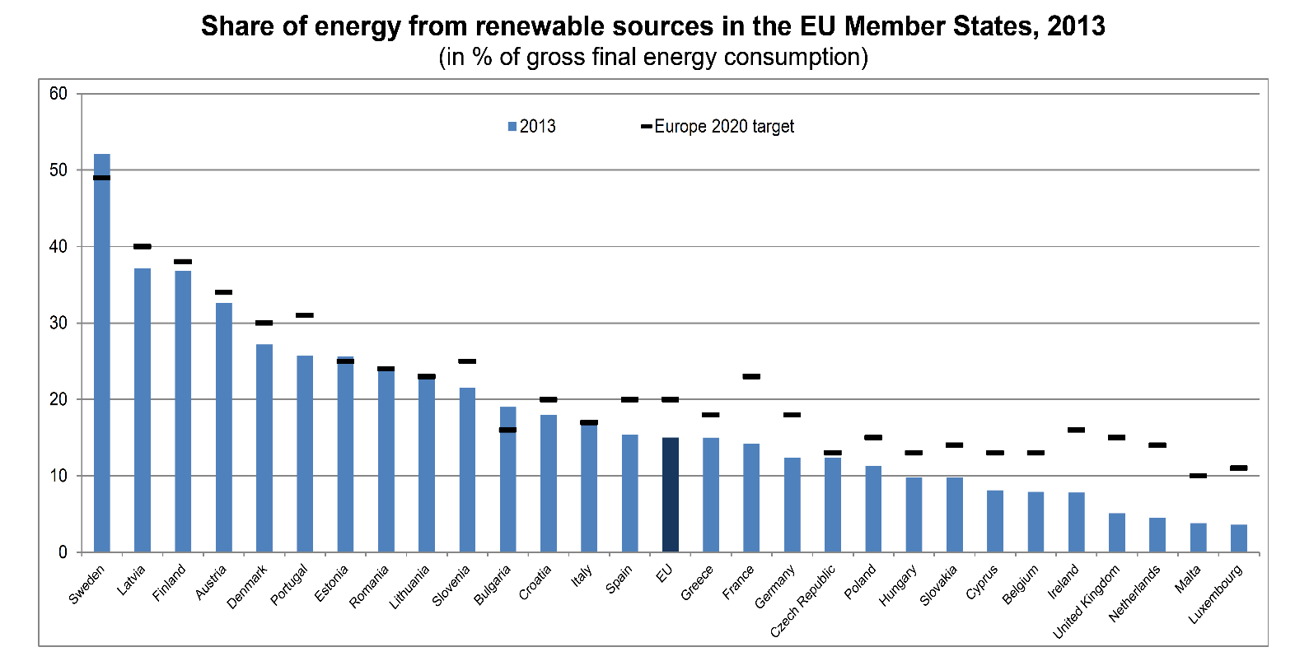

Austria’s overall energy intensity decreased by more than 30% between 1973 and 2013. Austria has clearly decoupled emissions from GDP and population growth and has the lowest energy intensity together with Irland, Denmak, UK and Italy. Today its energy intensity lies below the average of European OECD countries.

Austria is a signatory to the Kyoto Protocol. It also participates in the European Union’s (EU) burden-sharing agreement, with a target of –13% of greenhouse gas (GHG) emissions for the first commitment period 2008-2012, compared to 1990. In 2012 the Austrian emission were close to the 1990 emissions and decreased considerably since 2005. The GHG/GDP emission ratio of Austria is among the lowest in the EU-28 and OECD. Austria has clearly managed to decouple greenhouse gas emissions from economic growth, as GDP (at constant prices) has grown by about 60 % since 1990.

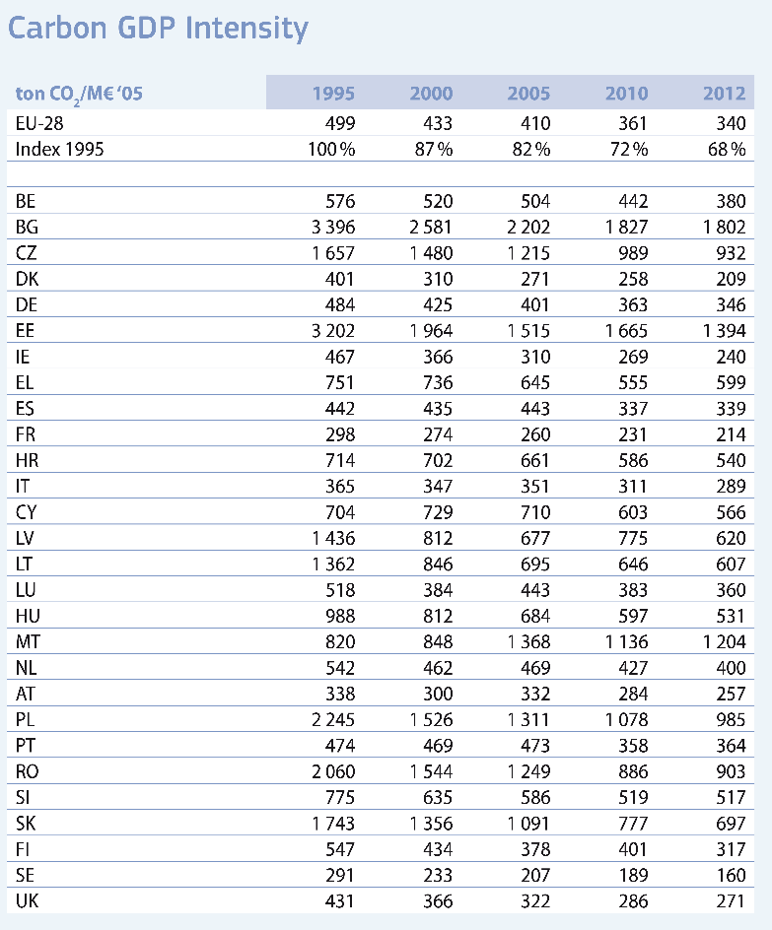

6.2 Enabling Policy Environment for Sustainable Energy
In the Austrian Energy Strategy the country has committed to achieve the following targets by 2020:
- A renewable energy share of 34% of final energy consumption; Austria reached already 32,6% in 2013.
- A 16% reduction of the greenhouse gas emissions (GHG) in sectors not subject to emissions trading;
- a 20% growth in energy efficiency.

In 2010, the Austrian Government has adopted an integrated energy strategy. Since many years, Austria makes use of economic support instruments for renewable energy such as a feed-in tariff (green electricity act 2003), tax exemptions and direct grants to investors on the federal and state levels. The support system is designed to promote particular technologies on the basis of their assumed costs, with the aim to make these technologies competitive. Moreover, Austria has adopted pioneering standards and support models for energy efficiency standards in buildings.
Since 2004, Austria is implementing the klima:aktiv program which aims at improving capacities, awareness raising and quality standards in the fields of efficient buildings, energy conservation, mobility, renewable energy. In 2007 the climate and energy fund with a volume of 500 million euro was launched.
National institutions based in Vienna take part or leadership in international sustainable energy partnerships of think-tanks. The Austrian Energy Agency is implementing the energy partnerships in Central and Eastern Europe. Austrian experts are engaged through different IEA implementing agreements and in several networks of excellence (ERA-Net on bioenergy, hydrogen, fuel cells, PV), EU technology platforms (bioenergy, PV, solar thermal, hydrogen).
6.3 Highly developed sustainable energy industrial value chains
SIDS DOCK can rely on a strong technology and know-how base in Austria. Austrian companies currently occupy a worldwide leadership role in some areas of renewable energy and energy efficiency (particularly all sizes of hydropower, solar thermal, bioenergy, heat pumps, waste to energy and energy efficiency in buildings). Currently around 200 companies (plant manufacturers) are active in the renewable energy sector in Austria.
To enhance their international competitiveness, companies and scientific institutions co-operate in regional energy clusters (such as Oekoenergie-Cluster Upper Austria, ECO World Styria, Energy Region Weiz-Gleisdorf and Cluster Renewable Energy Tyrol). Specialised interest groups such as the Austrian Biomass Association, IG Wind, Small Hydro Power Association, ARGE Renewable Energy, Photovoltaic Austria are lobbying for an favourable public and framework in Austria.
The sustainable energy sector is characterised by a strong growth of revenues and job creation. In 2007 the revenues of the renewable energy sector (excluding large hydropower) amounted to 1,6 billion euro. It is estimated that around 200.000 persons are working in the area of green jobs in Austria (such jobs are related to environmental services and renewable energy in general).
Austria´s sustainable energy sector is highly export orientated. Exports of solar thermal systems amount to more than 81% of total sales. The wind power industry exports more than 70%. In the case of pellet and wood chip heating plants the export share amounts to about 30 per cent nationwide, whereas the big Austrian manufacturers export more than 70 per cent of their production. About 30 per cent of the produced heat pumps - an Austrian invention- are exported worldwide.

6.4 Hub for sustainable energy applied research
Private and public R&D in energy technology has a long and strong tradition in Austria. It has been successful in creating world-class industries (e.g. for hydropower, solar thermal, biomass firing, heat pumps, components for wind power, efficient buildings). In 2007 46,5% of the overall public R&D spending was devoted to renewable energy (predominantly bioenergy and solar thermal) and 24,1 % to energy efficiency. The Austrian government has launched the implementation of a long-term comprehensive R&D strategy “energy 2050” in 2007.
Numerous institutes at 22 universities and 16 institutions are engaged in research on REN and EE. The most important are the technical universities in Vienna and Graz. In addition, two large publicly-owned research institutes operate in Austria: Arsenal Research and Joanneum Research, with 14 research centers, owned by the state of Styria. Research is also undertaken by the Austrian Energy Agency, ÖGUT, ARC Seibersdorf and AEE Intec.
Austrian industry is involved in R&D through a range of small and medium sized enterprises (e.g. bioenergy and solar thermal), as well as through large industrial companies — including Siemens, Andritz, VA Tech Hydro, Magna, and GE Jenbacher that are actively engaged in researching hydropower generators, power plant engineering, and constructing efficient power stations and control centers. Energy utilities are also stakeholders in energy R&D.
7. Smart City Vienna – Best City for Quality of Life (data to be updated)
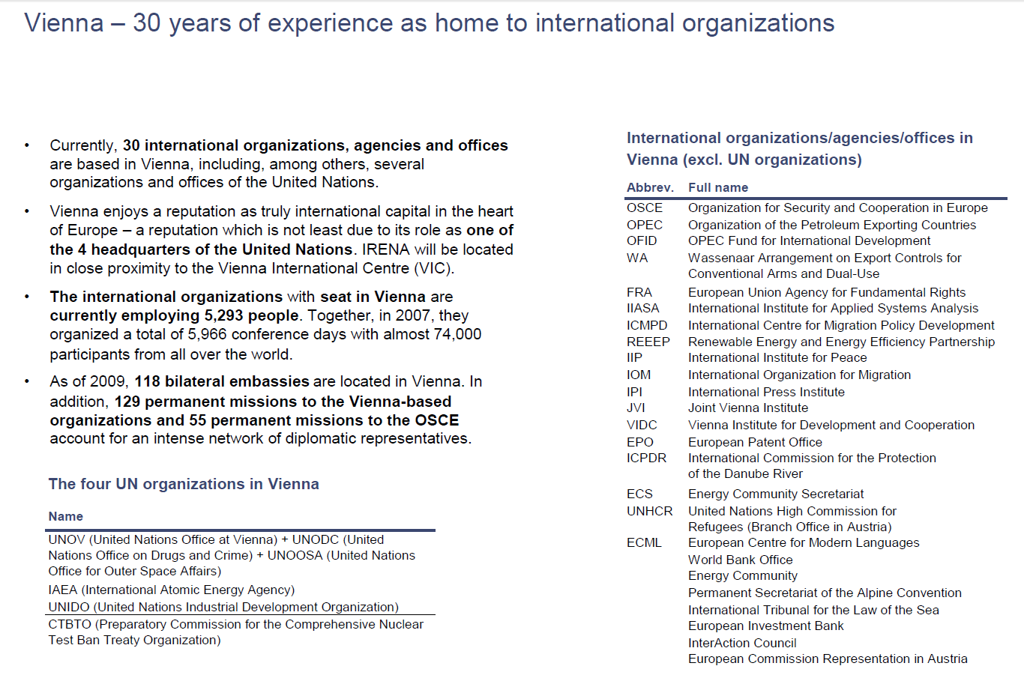
7.1 Hub for international organizations and conferences

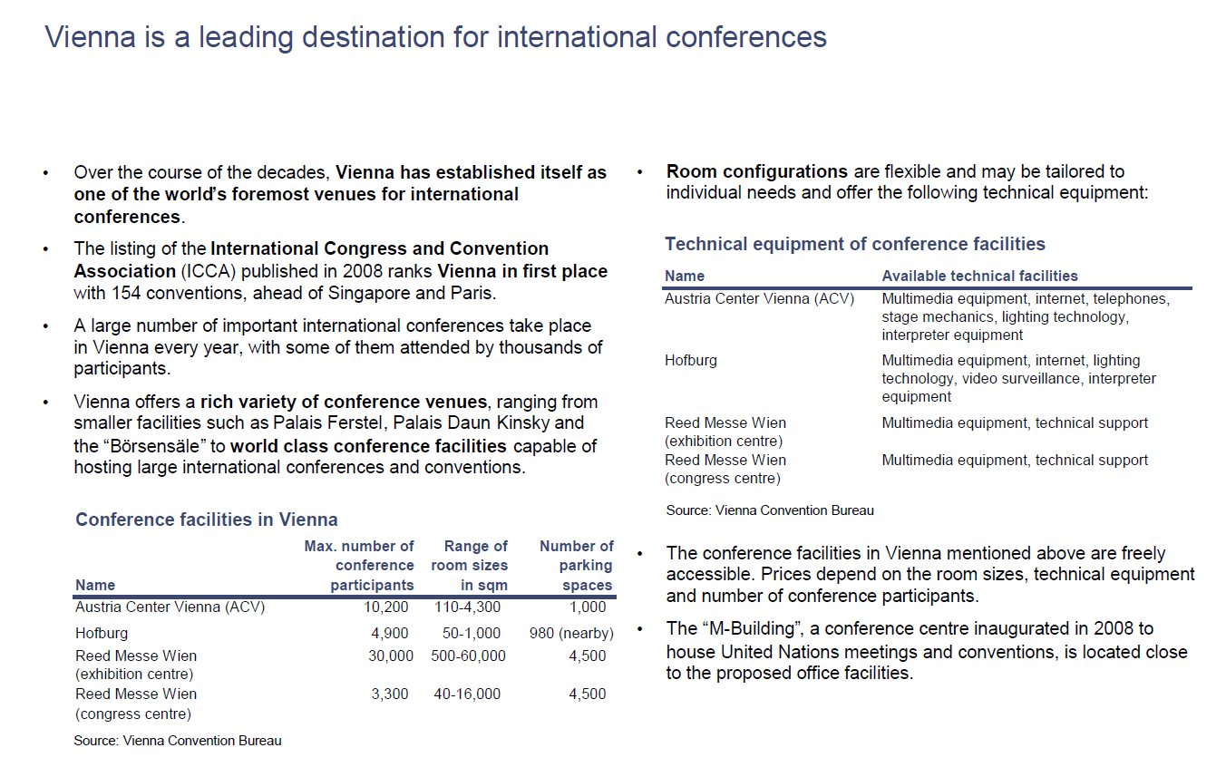
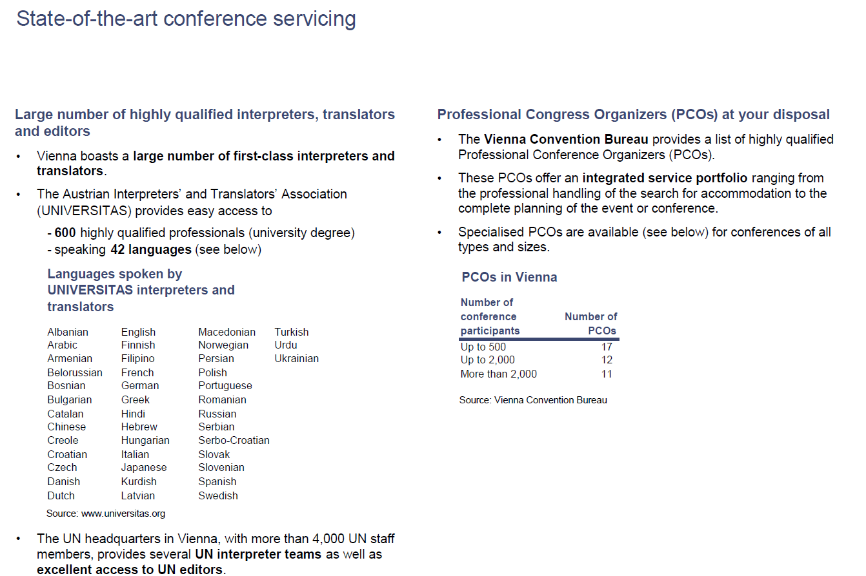
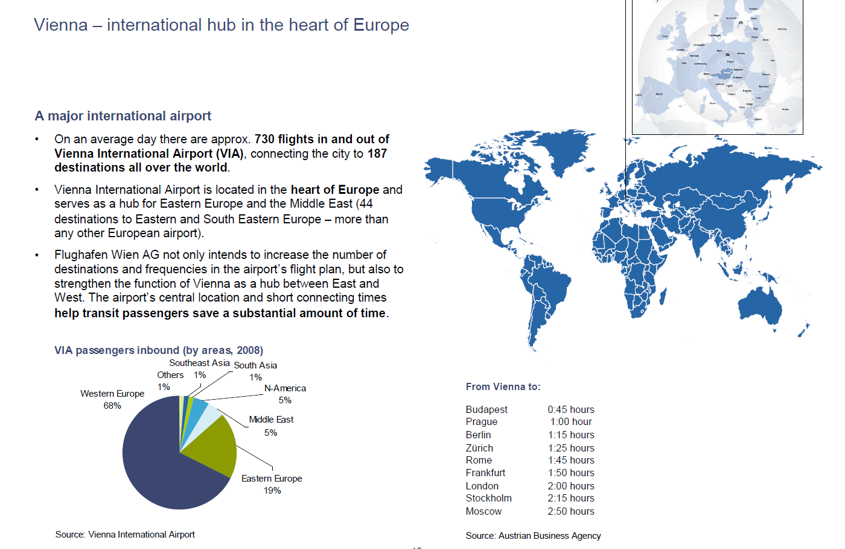
7.2 Well connected with the world
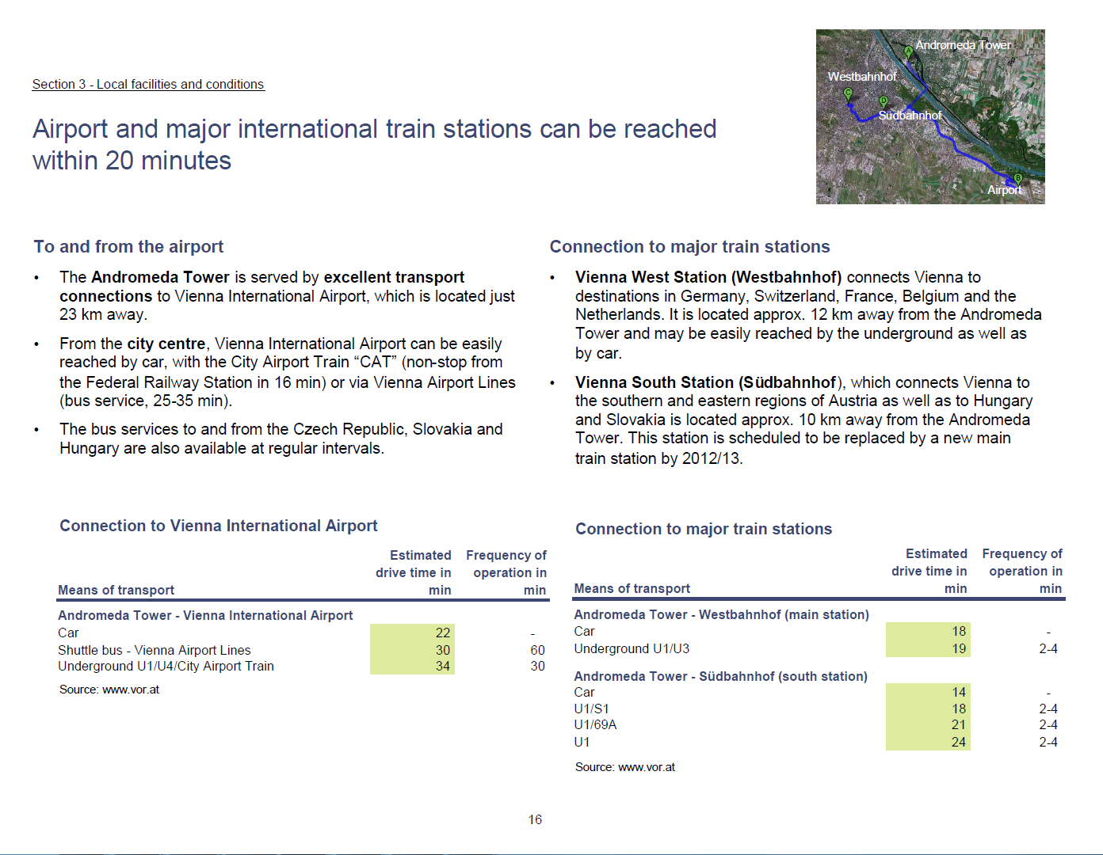

7.3 World Class Hospitality and Tourism
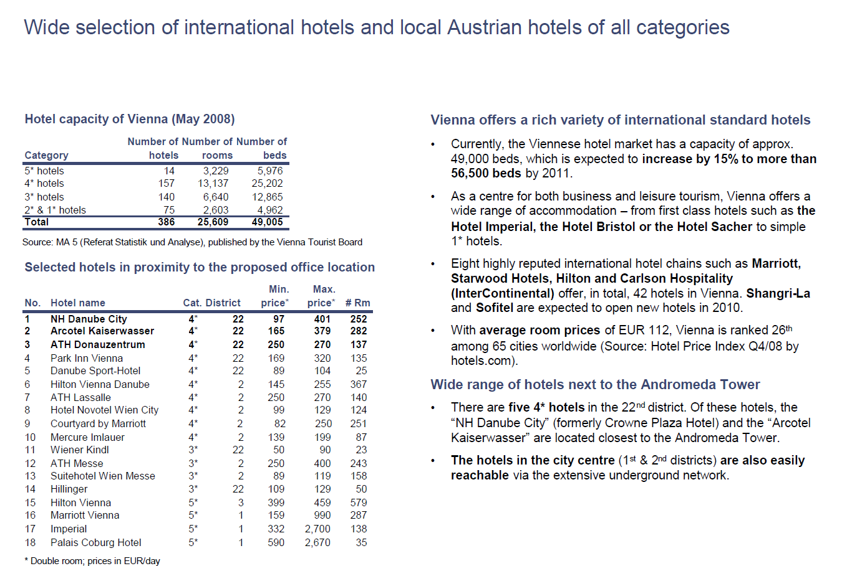
7.4 Excellent Education and Health Care
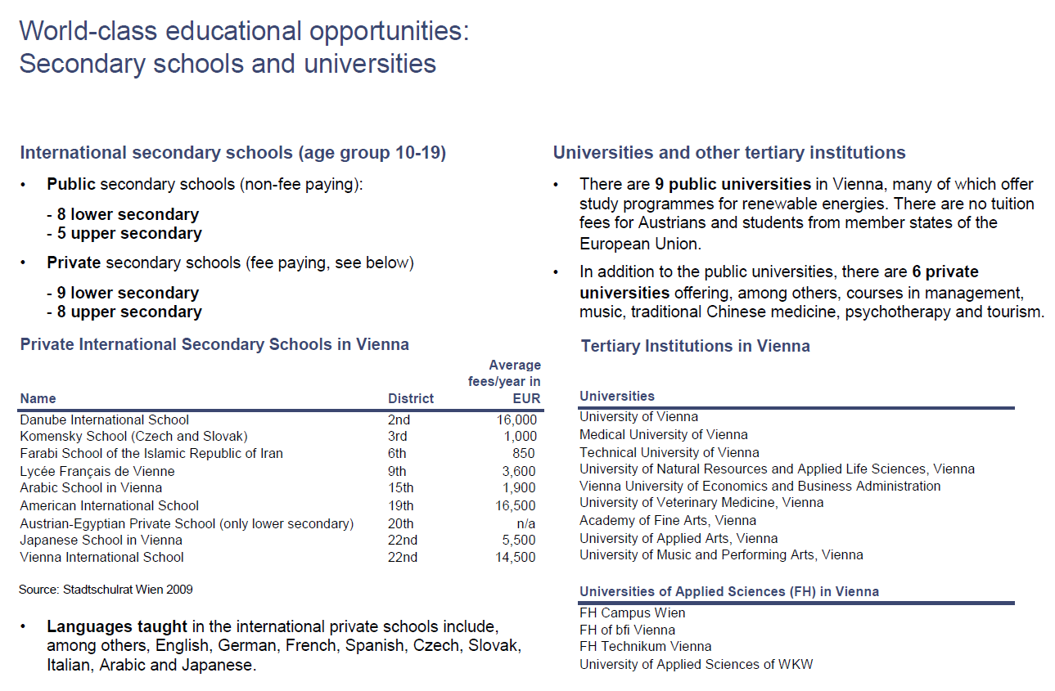
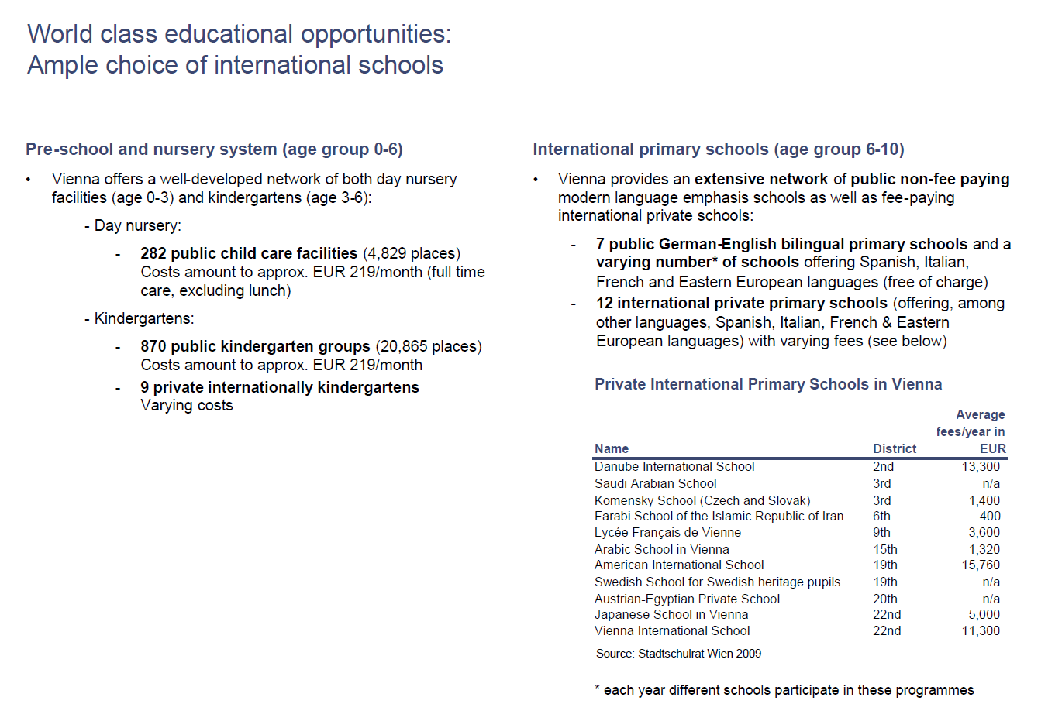
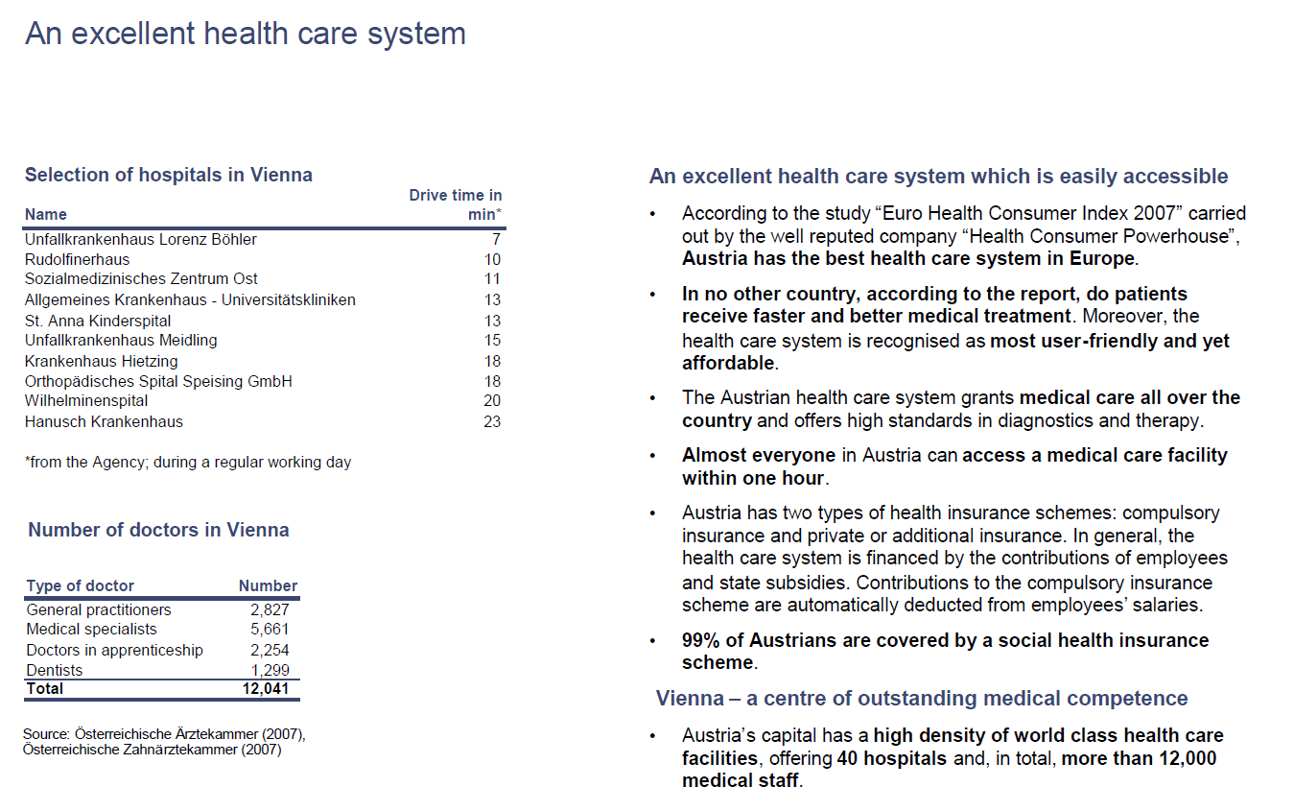
7.5 Affordable housing, qualified work force and banking system
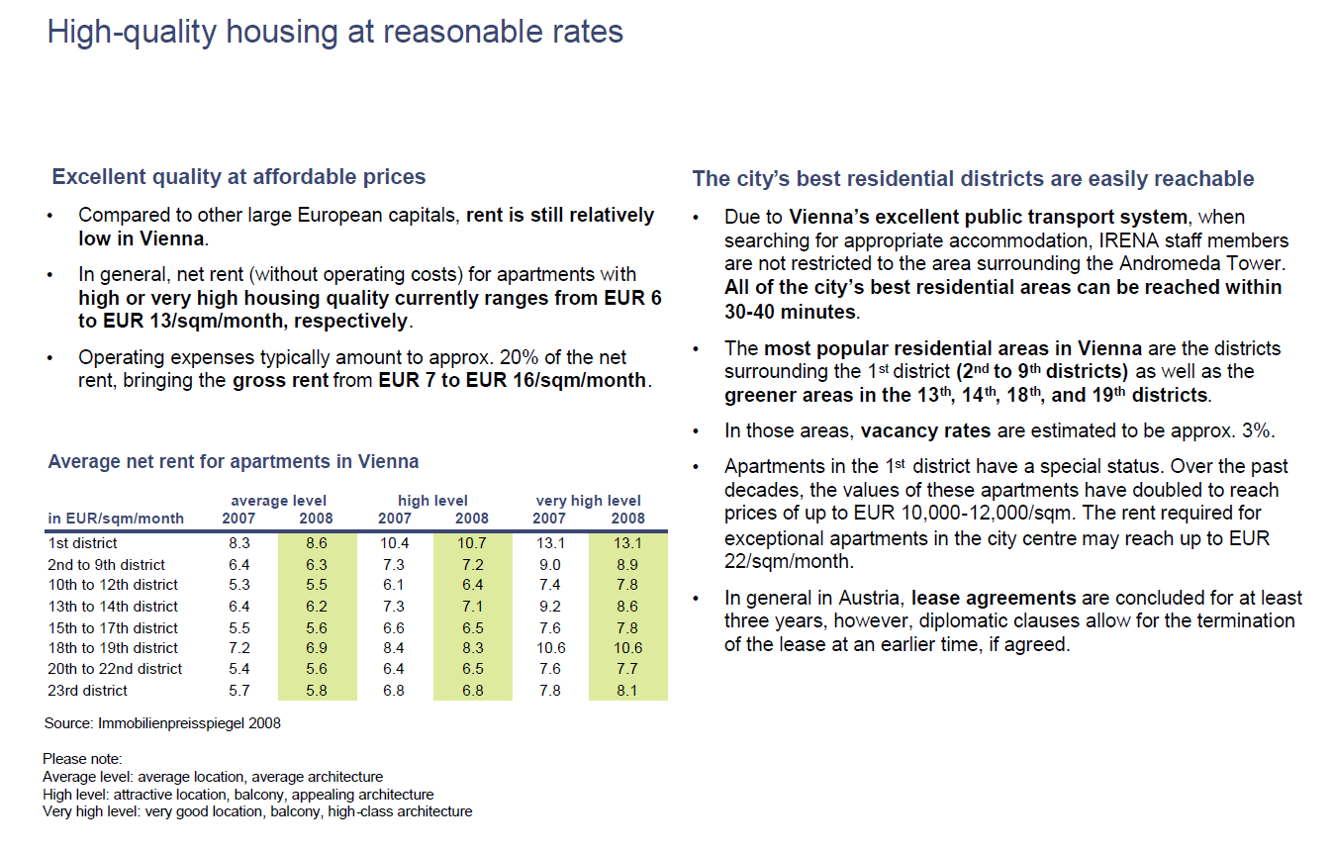
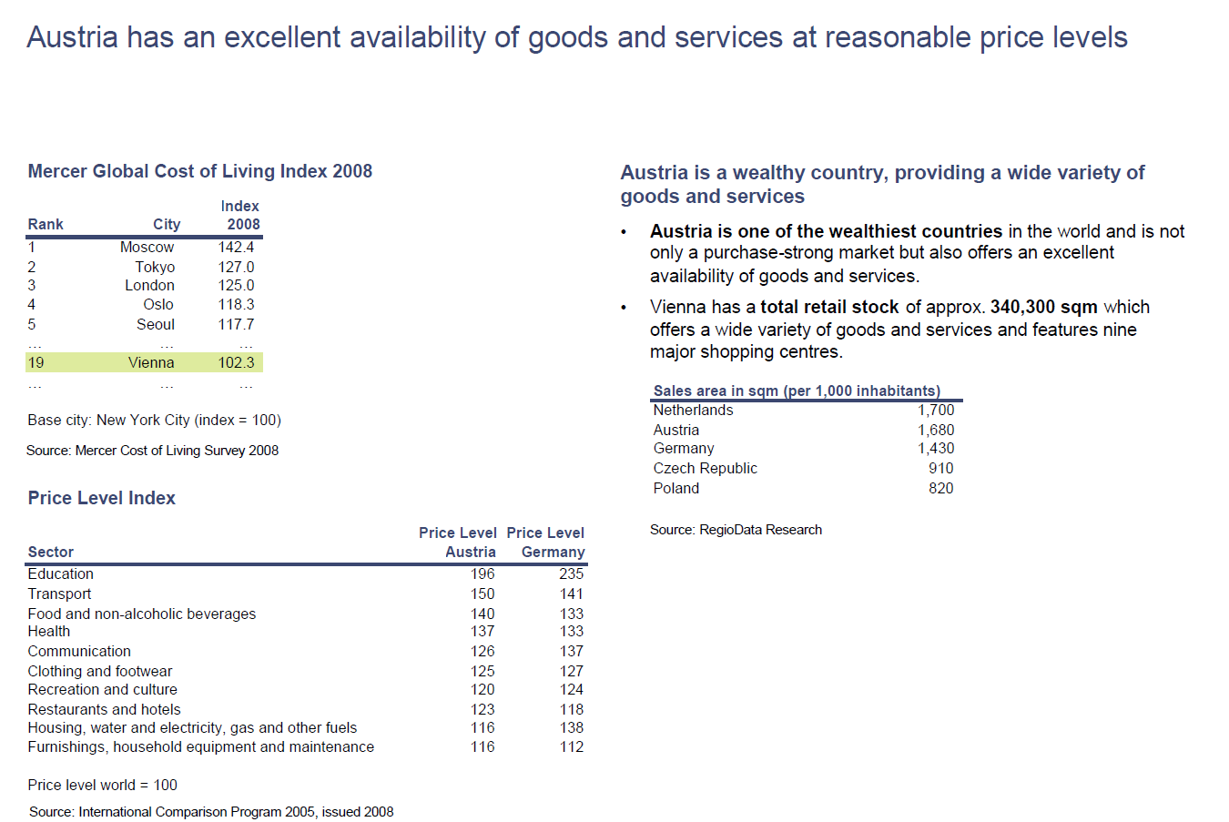
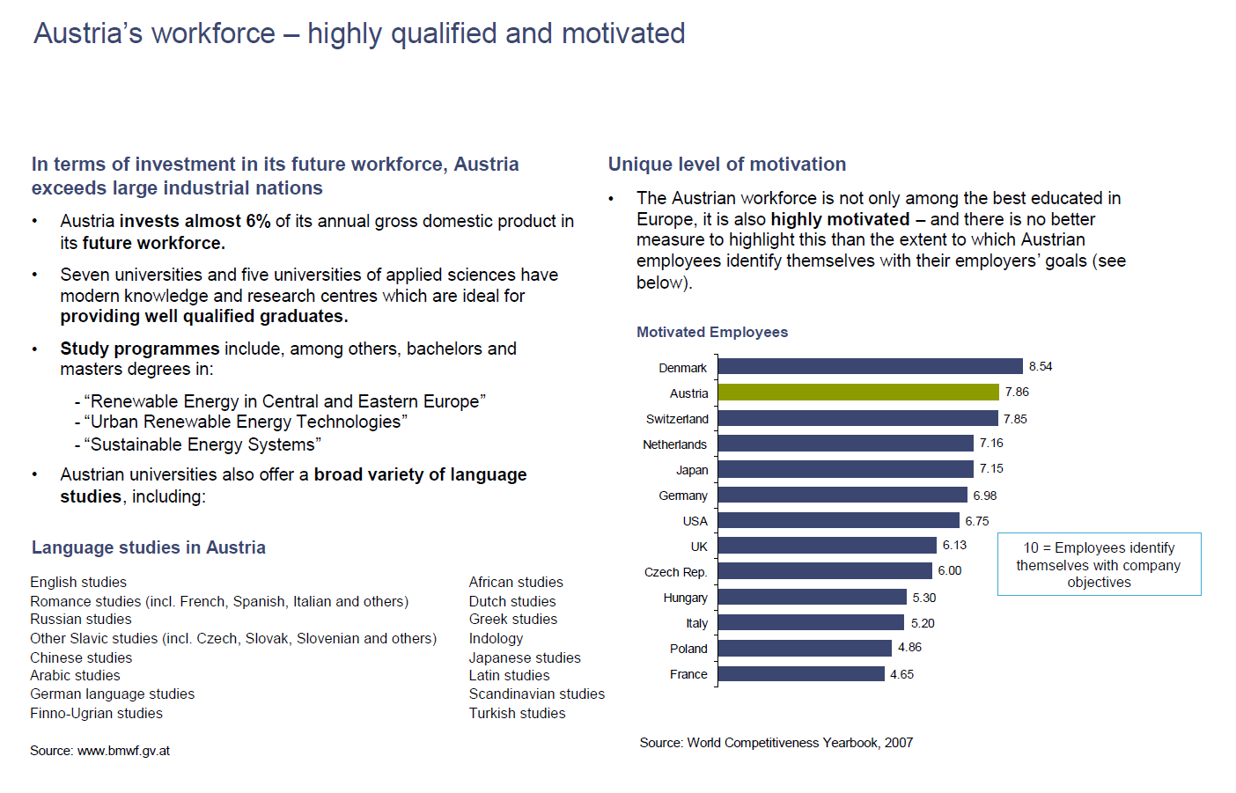

7.6 Best Quality of Life
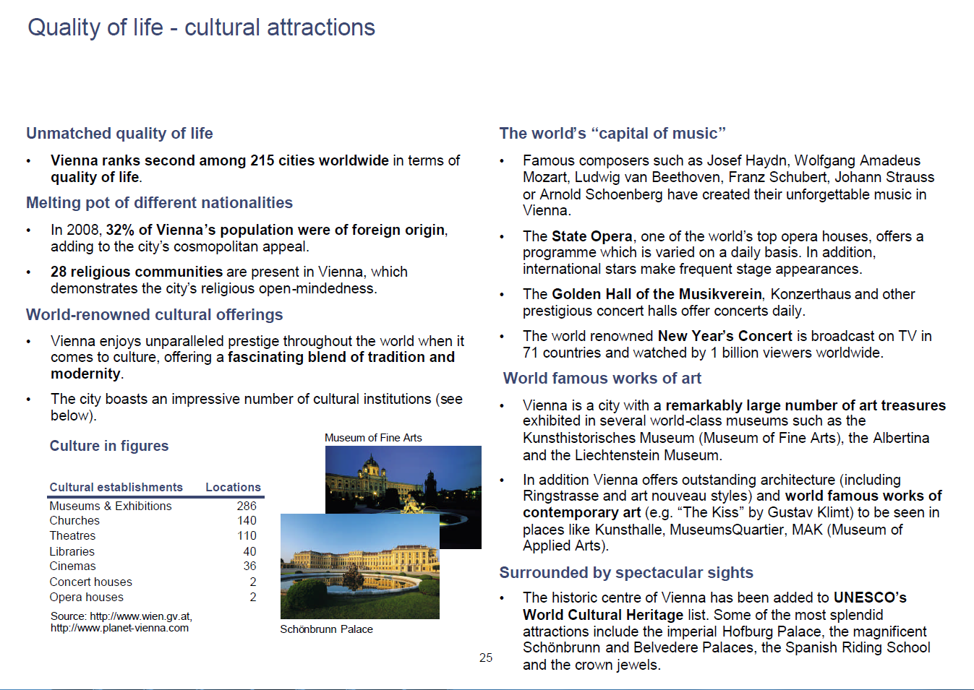
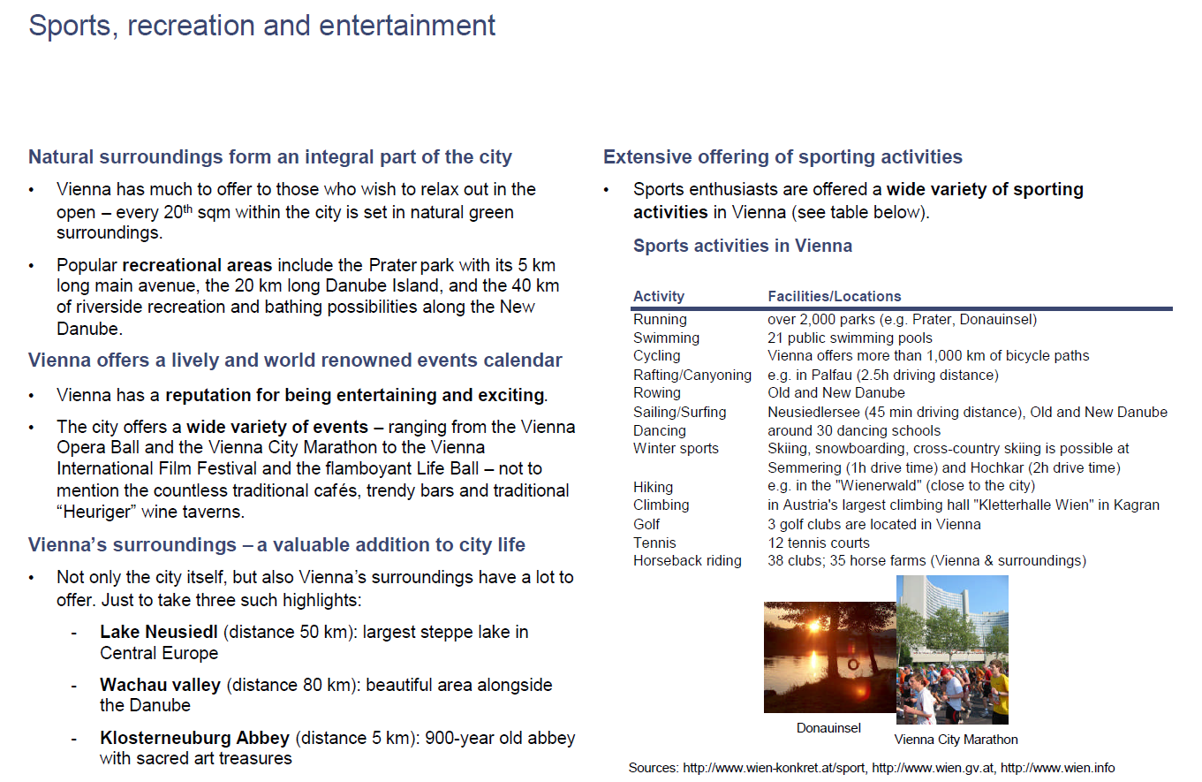

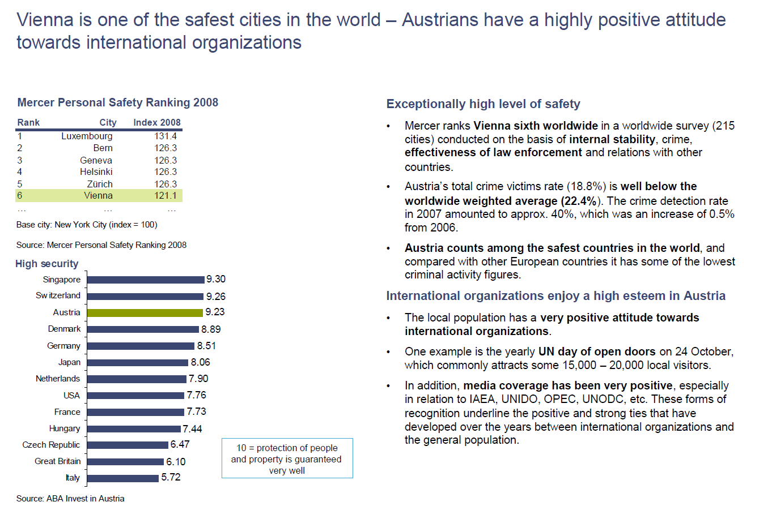

See also www.ccreee.org, www.pcreee.org and www.ecreee.org

