Third session of the SIDS DOCK Assembly
United Nations
New York, NY 10017
23 September 2017

SIDS DOCK WORK PROGRAMME

SIDS DOCK Renewable Energy Finance PlatForm (REFF):
Risk Financial Facility for Projects

SIDS DOCK, in partnership with regional development banks and the Caribbean Community Climate Change Centre (CCCCC/5Cs) and the Secretariat of the Pacific Environment Programme (SPREP), is preparing a funding proposal for the Green Climate Fund (GCF), to support a cross-cutting risk mitigation project initially focused on the Caribbean Community (CARICOM). In this connection, SIDS DOCK intends to seek a grant from the GCF’s Project Preparation Facility.

As a catalyst for sustainable development, SIDS DOCK is developing a Risk Mitigation Platform to address sustainable energy and climate change challenges and mobilize private investment for renewable energy and efficiency projects in CARICOM. The Platform will be built on three pillars:
- Risk Mitigation Facility: providing credit enhancement and risk mitigation instruments to enable bankability of renewable energy and efficiency projects;
- Co-Financing Facility: providing co-financing of project equity and debt to support small standalone projects and the participation of local developers;
- Technical Assistance Facility: providing technical assistance to address regulatory and legal bottlenecks, institutional capacity deficits and the shortage of risk capital.

The Platform is a public-private partnership (PPP) that will leverage international donor, multilateral and climate-focused stakeholders to crowd-in direct private investment. By helping CARICOM Member States to overcome financial, technological and regulatory obstacles, the Platform will play a critical role in facilitating the transition to a sustainable energy economy.

The Platform is both scalable and replicable. Although the initial geographic focus will be on the Caribbean region, the Pacific and Africa and Indian Ocean regions will be considered in subsequent phases of work. Further, as a SIDS-owned project that takes a risk mitigation approach, the Platform represents a paradigmatic shift from existing financing for climate mitigation in SIDS.

SIDS DOCK is preparing a funding proposal for the GCF to support the Platform with anchor equity. To this end, SIDS DOCK proposes to submit a [USD 500,000] grant from the GCF’s Project Preparation Facility, to finalize the project design and structuring and complete due diligence.

Background and problem definition | Small Island Developing States (SIDS) are among the most petroleum-dependent nations in the world, spending more than 30 percent of annual foreign exchange earnings on hydrocarbons, reducing energy security, increasing macroeconomic vulnerability and leading to exorbitant electricity tariffs. At the same time, SIDS are at the leading edge of climate change, suffering disproportionately from rising sea levels and weather-related disasters.  SIDS are facing acute challenges in the power sector. Energy tariffs are among the highest in the world due, primarily, to a reliance on expensive imported petroleum products. This constrains economic growth, increases external debt and contributes to high levels of greenhouse gas emissions. Further, although access to electricity is generally high (>90%, with the exception of Haiti), off-grid back-up systems are commonly used due to frequent black-outs and low reliability of grid networks.  Renewable energy is particularly suited to SIDS as it offers a practical solution: it fits utility and small-scale projects, costs are competitive with traditional sources of energy and it is specifically adapted for decentralised power networks, such as that of small islands.  There is significant technical potential for renewable energy across the region which has been recognised by national governments and reflected in their NDCs. Realising this potential would result in a significant reduction in expenditure on petroleum products, alleviating constraints on GDP growth and improving trade balances. It would also advance “true” electricity access (i.e. availability of electricity, not just a connection).  However, this potential is far from being achieved. Investment in new renewable energy capacity requires significant upfront capital expenditure, which many national utilities and governments cannot currently afford. Private sector involvement is therefore crucial but, with few exceptions, there has been relatively little private investment to date in the Caribbean renewable energy sector. This is due to a number of factors including:  - A shortage of local development capital for renewable energy project developers;  - Limited access to long-term debt, equity and risk mitigation instruments due to high perceived risk and transaction costs;  - Institutional capacity constraints to develop enabling environments for private sector participation.
Proposed solution | The SIDS DOCK Renewable Energy Finance PlatForm (REFF) would provide a targeted suite of products to support the development of renewable energy projects in SIDS and encourage local economic development by overcoming the barriers identified above and mobilising private sector finance. The Platform will be built on three pillars:  - Risk Mitigation Facility: providing access to credit enhancement and risk mitigation instruments to enable bankability of renewable energy and efficiency projects. These include: liquidity support to cover non-payment and payment delays under project PPAs; PPA guarantees to cover breach of contract and changes to RE legislation and tariff structure; and political risk insurance.  - Co-Financing Facility: providing co-financing of project equity and debt to support small standalone projects and to encourage the participation of local developers.  - Technical Assistance Facility: providing technical assistance to address regulatory and legal bottlenecks, institutional capacity constraints and the shortage of risk capital. The facility will support public sector institutional capacity building whilst at a project level provide finance for third party development costs (e.g. ESIAs, feasibility studies).  Platform Overview:  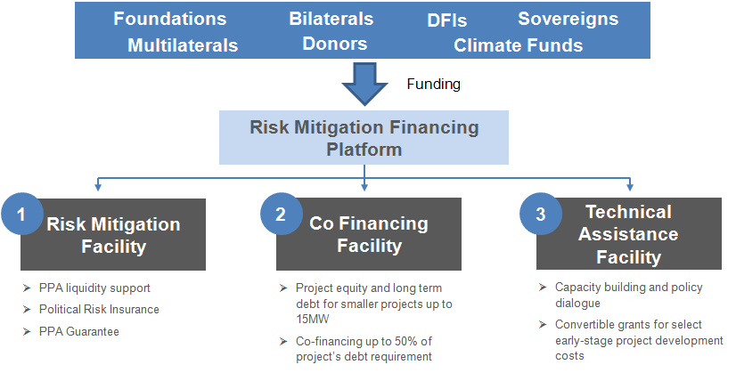
Organisations Involved | REFF is a public-private-partnership and will be led by SIDS DOCK and Camco Clean Energy.  SIDS DOCK is an international organisation established to encourage sustainable energy in Small Island Developing States by connecting the energy sectors with the global markets for finance and sustainable energy technology.  SIDS DOCK was established by Statute on 1 September 2014, signed initially by 20 states, during the United Nations Third International Meeting on Small Island Developing States, held in Apia, Samoa. The Statute came into force on 27 September 2015, and members convened at the 70th United Nations General Assembly in New York, on 30 September, to commemorate the formal recognition of SIDS DOCK as an intergovernmental organisation vested with the full powers of the United Nations.  Camco is a fund advisory business specialised, and with over 25 years’ experience in, renewable energy development, finance and policy in emerging markets. Camco currently provides fund management, technical assistance and advisory services to donors, governments, local developers, industry, multinational companies, investment banks and regulatory bodies across the globe. Camco is FCA regulated and is a subsidiary of redT energy plc, which is listed in London.  SIDS DOCK will work with Camco to develop REFF, drawing on Camco’s current experience of implementing and managing the £48m Renewable Energy Performance Platform (REPP). REPP was developed by the United Nations Environment Programme and the European Investment Bank to deliver the UN SE4All objectives in sub-Saharan Africa by supporting small and medium scale renewable energy projects in countries throughout the region.
Support needed | Development of the REFF has to date been undertaken by SIDS DOCK. Additional funding is now needed to further develop the concept to operationalise REFF and undertake pilot projects.  Project Design Finalisation  - Market Study and development of Business case  - Financial Model and Business plan  - Operating Policies and Procedures  - Platform Operations Manual  - Product Development  - Indicators to track progress of the Platform and initial targets.  - Initial outreach and marketing plan. This activity will include development of an initial pipeline of projects seeking support.  - Recruitment of Management Board and Investment Committee members  - Timetable for implementation and next steps, including fund raising and Platform launch  - Development of a pipeline  Risk Assessment  - Risk assessment matrix (risk factors, risk contributors, mitigation & contingencies) for Platform implementation and operation  Advisory Services / Due Diligence  - Legal assessment of different options for the structure of the Platform and establishment of legal entity and associated documentation.  - Financial and tax assessment of different options for the structure of the Platform.  Pilot Projects  Support is also needed for pilot projects to ‘road test’ the products developed. The team will originate 1-3 projects based on their need for products in each of the three Facilities included in CREFF. The pilot project will be taken through the project support process to ensure the suitability and usability of the templates designed. It will also test the appropriateness of the products to be offered through the Platform and the likely up-take of them by developers. Following the pilot phase, the pilots and products will be refined where necessary based on feedback from the stakeholders.
CREFF Benefits | A fully funded and operational REFF, it is anticipated, could support development of up to 250MW of new renewable energy capacity over 5 years. This is expected to lead to:  - Avoided CO₂ emissions of over 500 000 tonnes each year  - Creation of over 4000 new jobs during construction and operation phase  - Reduction in cost of debt of over $150 million US for developers  - Cost savings for host country governments through reduced expenditure on new thermal power plants and fossil fuel imports  REFF:  - Is scalable and replicable;  - Takes a risk mitigation approach, providing for a greater leveraging of private sector finance and a paradigmatic shift from existing financing for climate mitigation in SIDS;  - Helps SIDS to overcome financial, technological and regulatory obstacles, creating an enabling environment for low emissions development;  - Is a public-private-partnership with strong SIDS ownership;  - Will play a key role in facilitating the transition to a sustainable energy economy, supporting regional growth, poverty alleviation, private sector expansion and increased resilience to climate change.

www.repp-africa.org

